**ABOUT US**

VISION

To be the premier destination for nurturing vibrant smiles, ensuring optimal dental health, and radiating confident beauty within our community.

MISSION

Providing quality dental care to relieve patients from aches and enhance their quality of life. We offer preventive, interceptive, and corrective dental treatments, aiming to reduce disability and improve overall well-being

ASTON PROMISE

വിദഗ്ദ്ധ ഡോക്ടർമാരുടെ സേവനത്തിൽ നൂതനവും മികച്ചതുമായ ദന്ത പരിരക്ഷ നൽകുന്നു. വേദനരഹി തവും സുഗമമായതുമായ സേവനം നിങ്ങൾക്കുറപ്പു തരുന്നു. പുഞ്ചിരിക്കൂ വിശ്വാസത്തോടെ.

**DOCTORS**

**SPECIALISTS**

* Dr Salahudheen Nadakkavil MDS

Root Canal Specialist

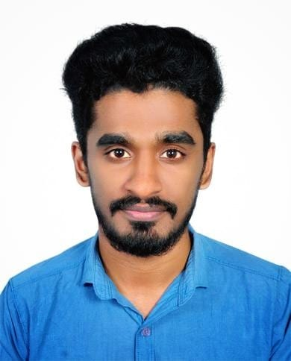

* Dr Reshma MDS

Pediatric Dentist

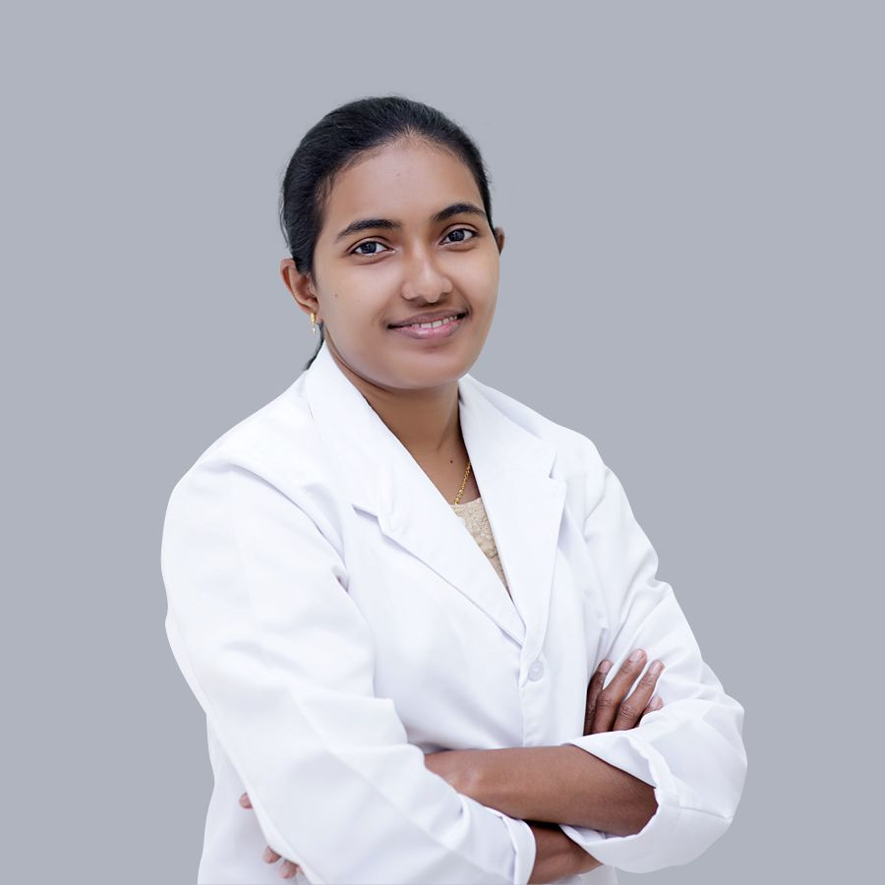

* Dr Nishad P MDS

Root Canal Specialist

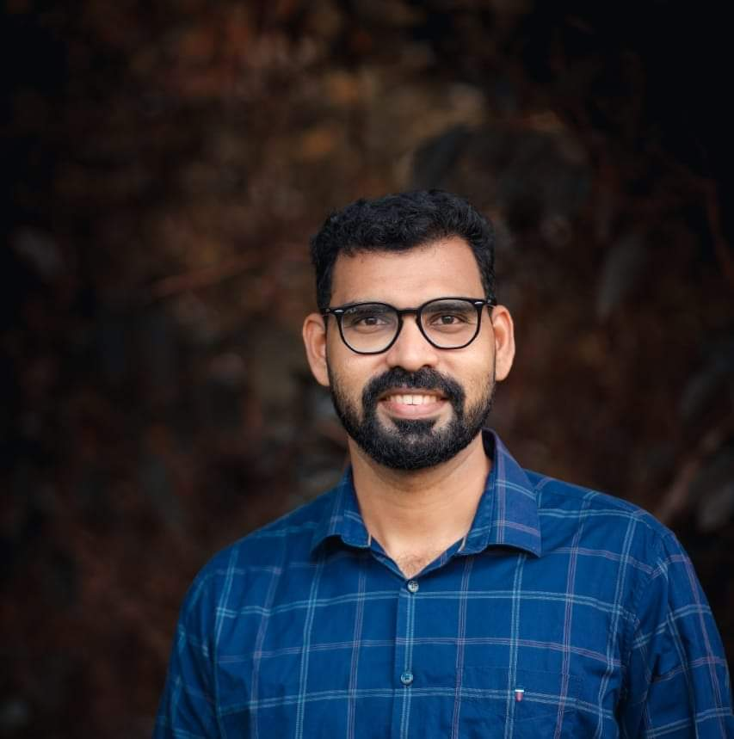

* Dr Shameer MDS

Periodontist

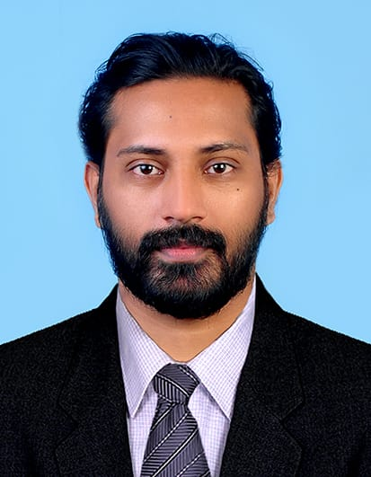

* Dr Vyshak G Das MDS

Prosthodontist and Implantalogist

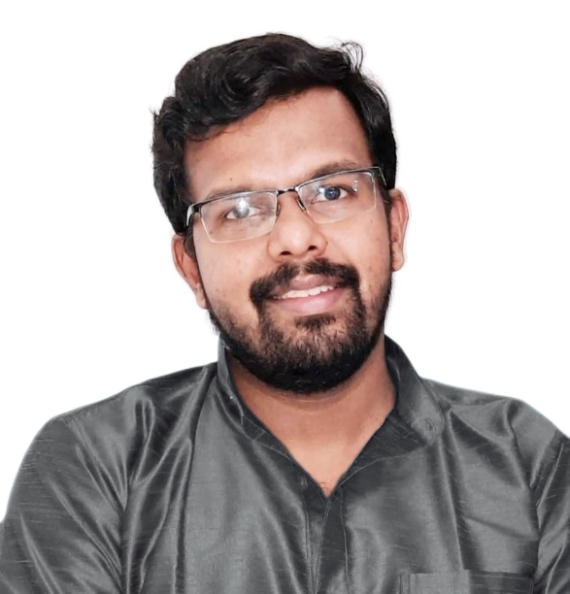

* Dr Muhammad Anas C. P MDS

Orthodontist

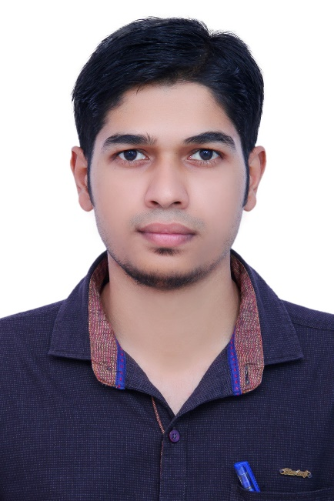

DOCTORS- Resident Dental Surgeons

1. Dr Shahul Hameed K BDS

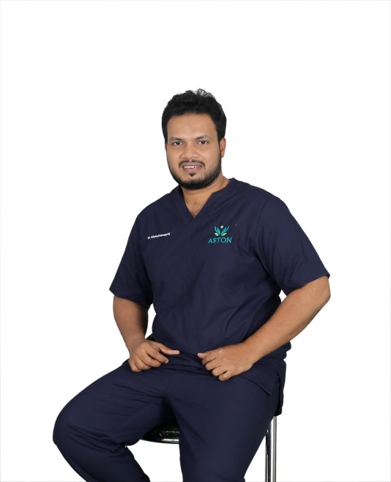

2- Dr Faizal PK BDS

Resident Dental Surgeon

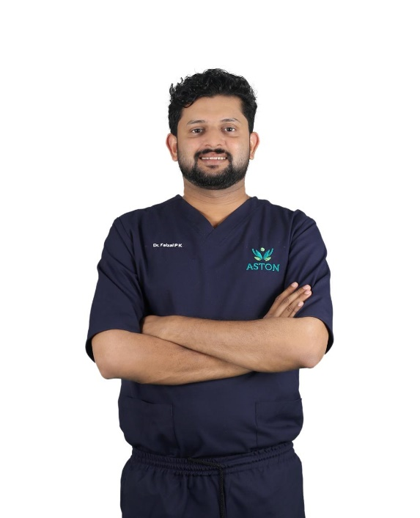

3- Dr Mubaris P BDS

Resident Dental Surgeon

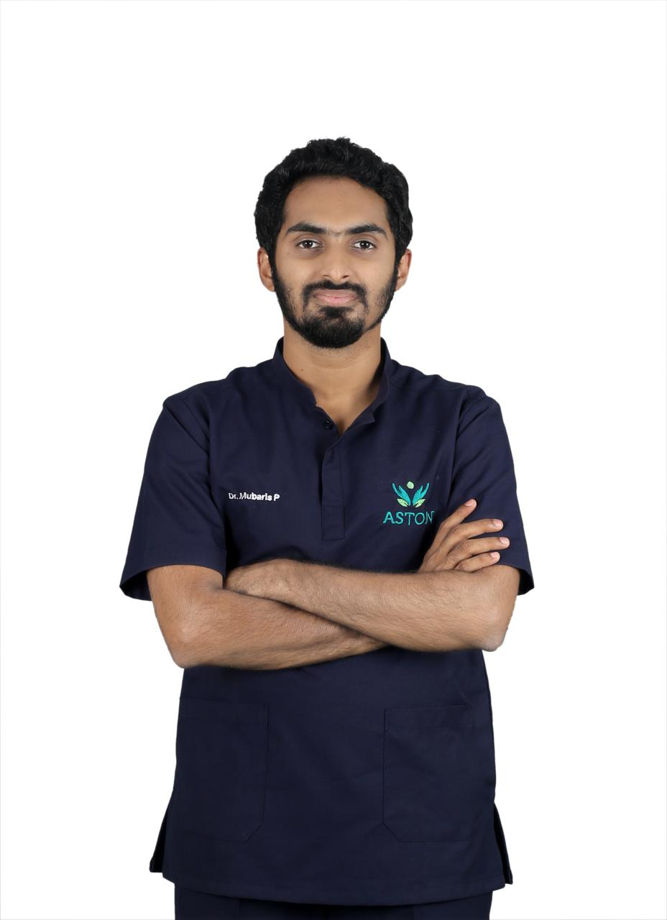

4- Dr Farook Rahman K BDS

Resident Dental Surgeon

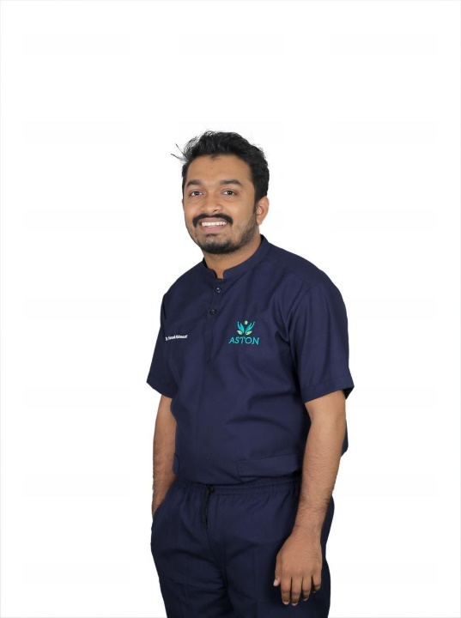

5. Dr. Fasalu Rahiman PK BDS

Resident Dental Surgeon

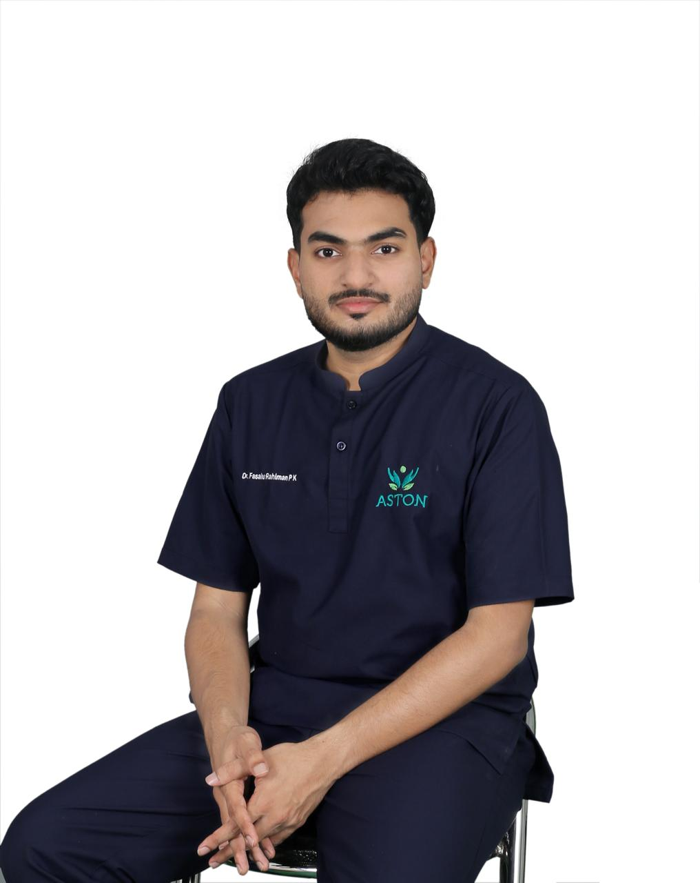

**SERVICES**

1. MERCURY FREE RESTORATION (TOOTH COLOURED FILLING)

Tired of these black or grey mercury containing silver amalgam filling? Now a direct filling is done with a tooth coloured material.

It is strong and bonds to the tooth structure.

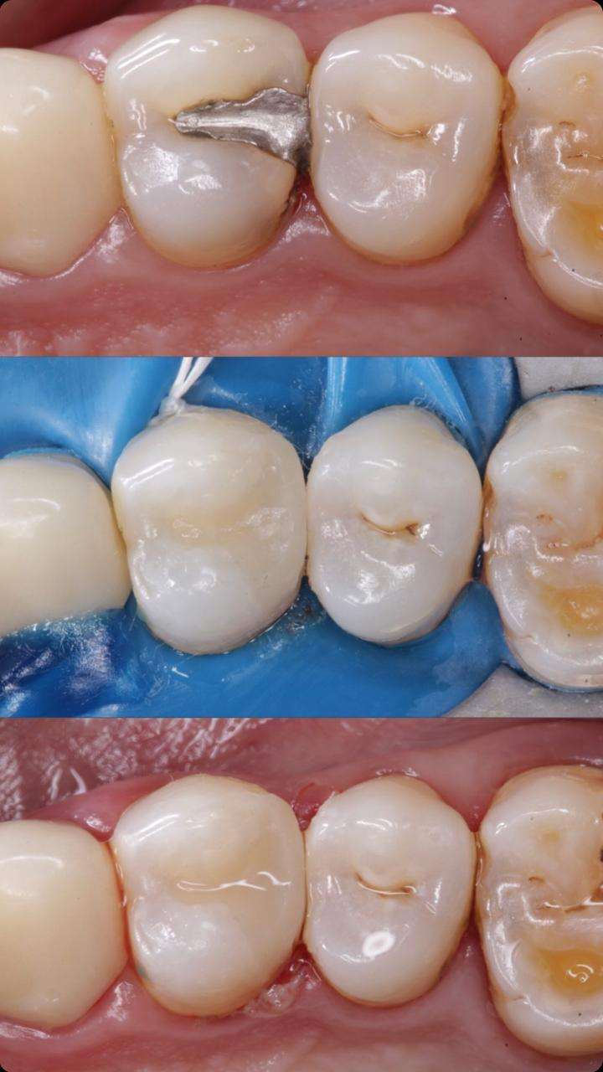

1. FIXED ORTHODONTIC TREATMENT

Dental treatment that corrects improper positioning of the teeth by using dental braces/mechanical aids and helps in giving a beautiful smile.

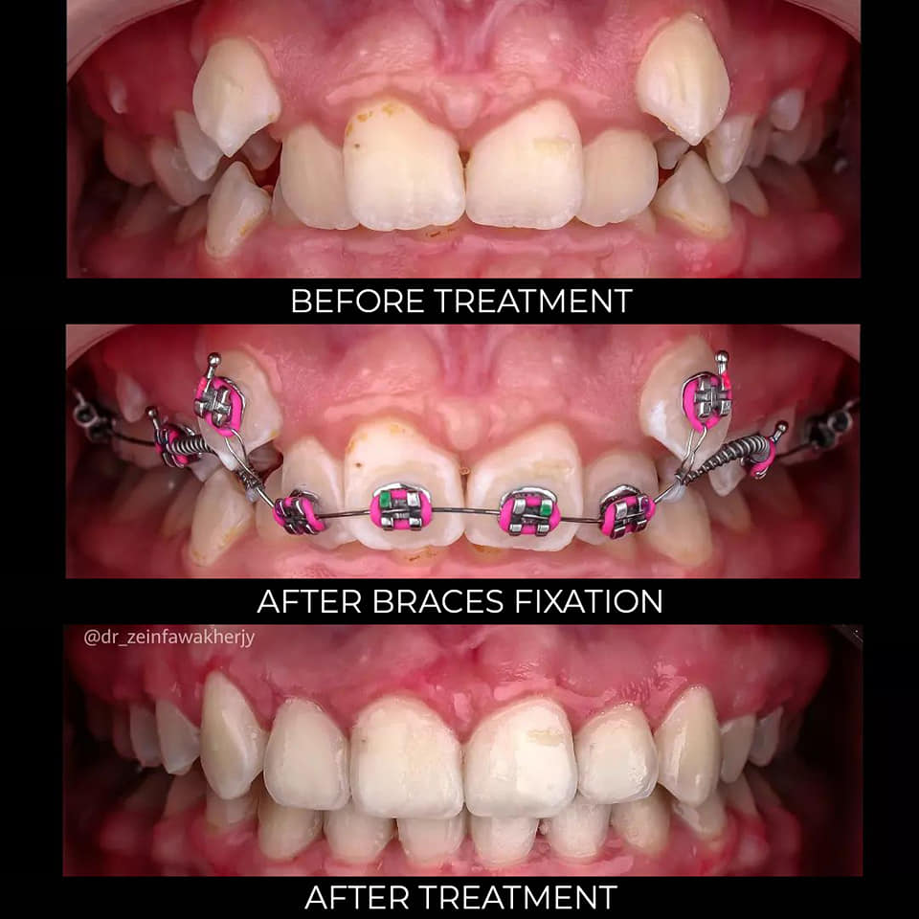

1. DENTAL IMPLANTS

Modern dental treatment in which a missing tooth is replaced by, placing artificial tooth root into the jaw bones

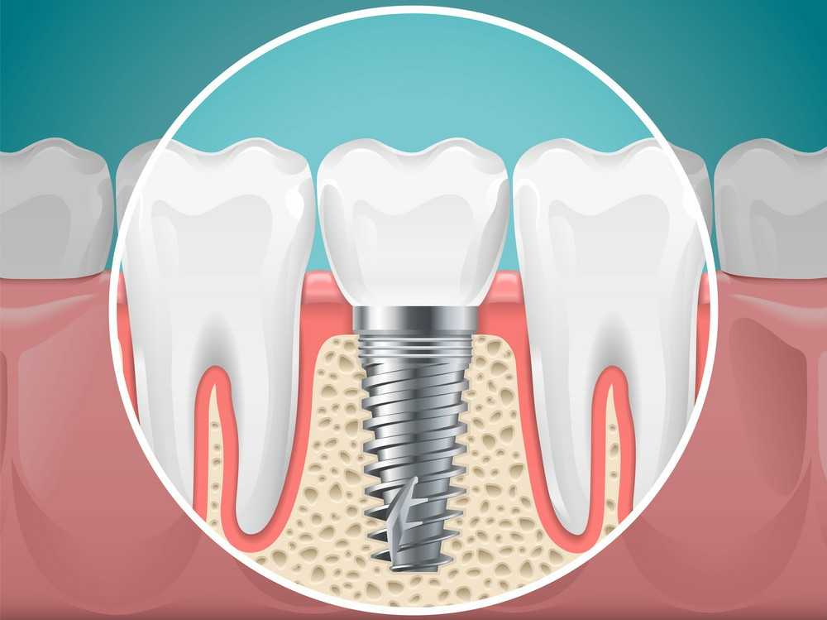

1. CROWN AND BRIDGE

Crown is a tooth shaped "Cap" that is placed over a tooth.

Bridges are fixed artificial teeth used to replace missing teeth.

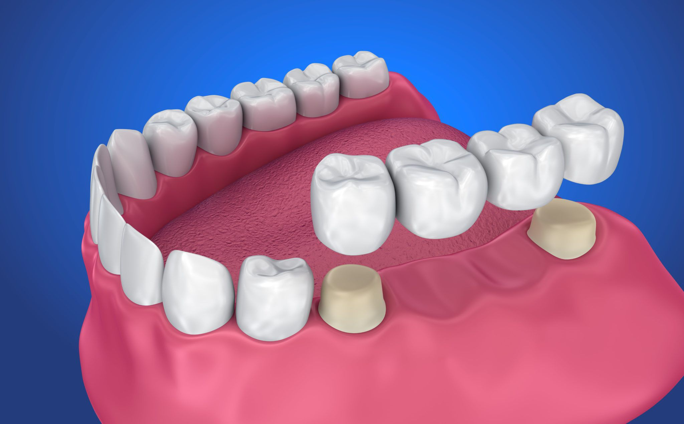

1. ROOT CANAL TREATMENT

Is a treatment used to repair and save tooth, which is badly decayed or infected.

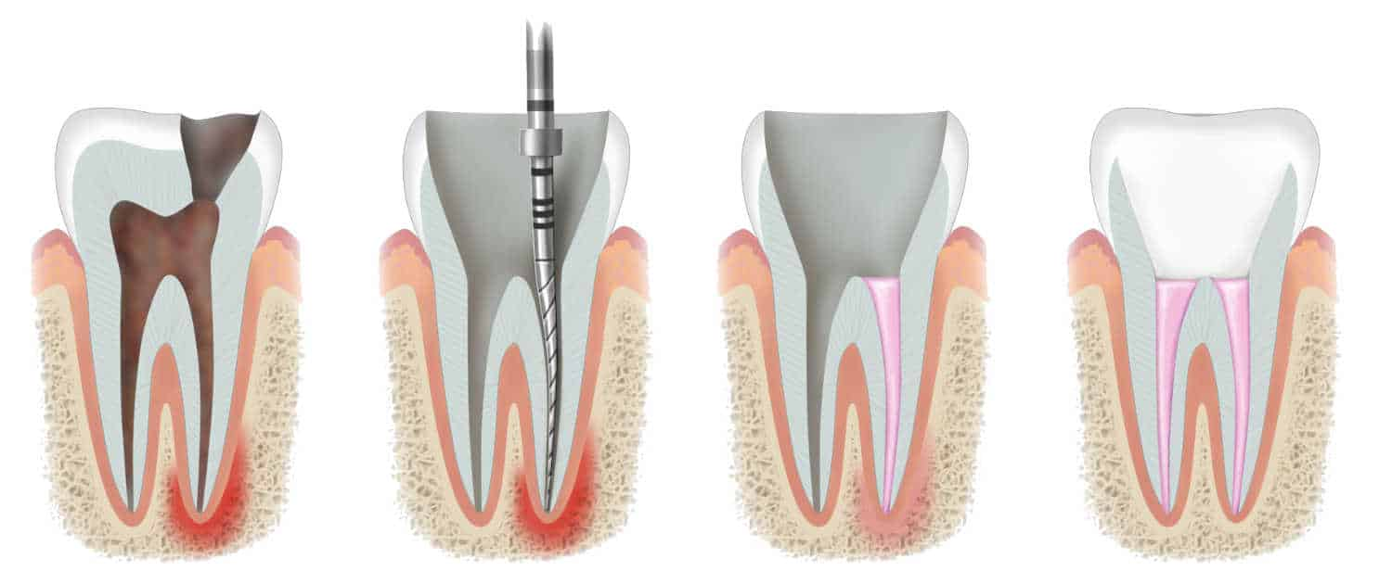

1. COMPLETE DENTURES

Dentures are removable appliances that can replace missing teeth and helps to restore your smile.

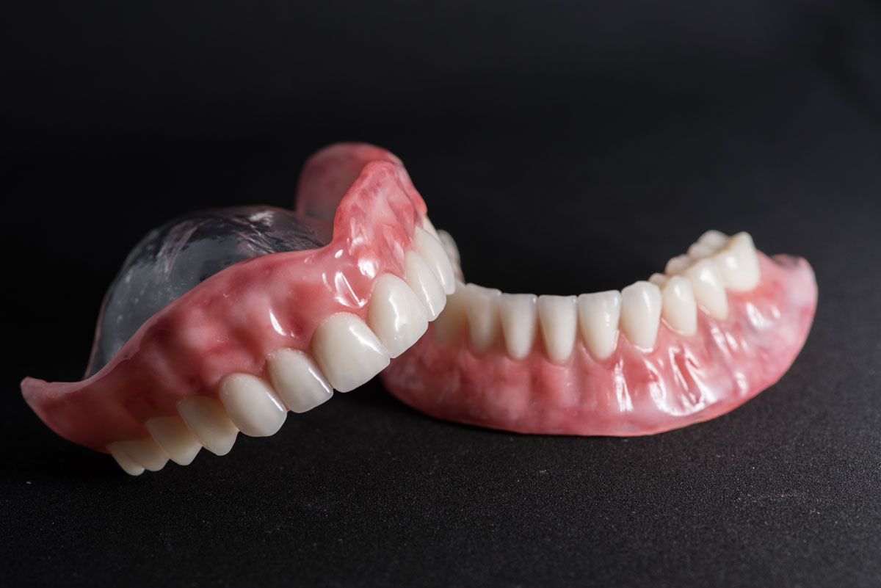

1. ULTRASONIC SCALING AND POLISHING

Cleaning and polishing of teeth without damaging the enamel

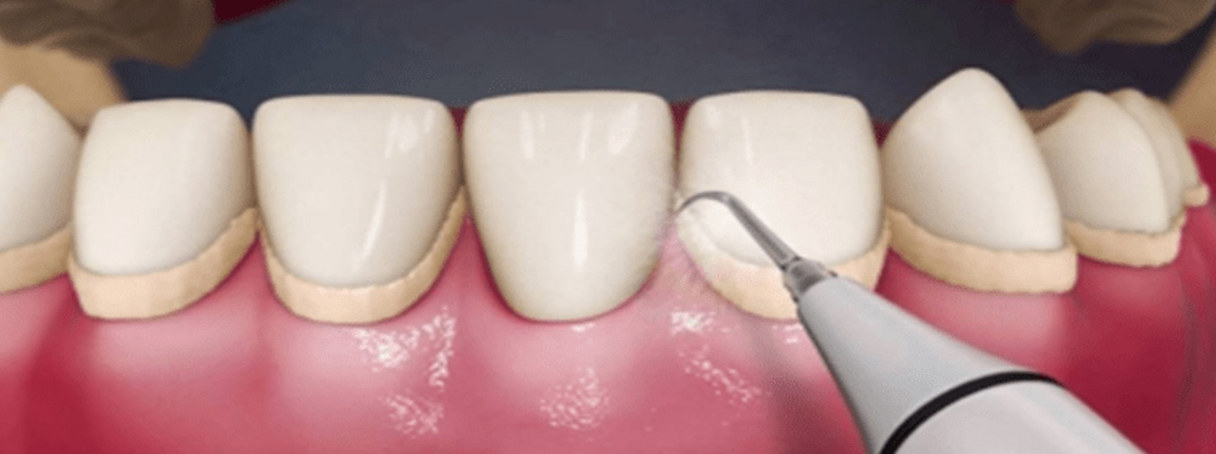

1. PERIODONTAL SURGERY

periodontal surgery is the removal of bacterial plaque and calculus (tartar)around the teeth and below the gum-line.

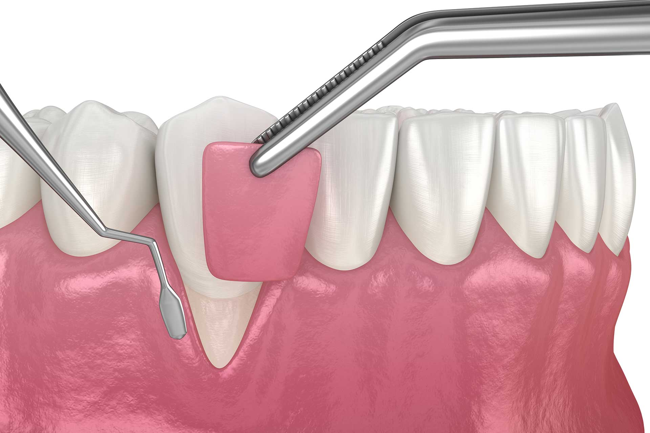

1. MAXILLOFACIAL SURGERY

Branch of dentistry, where jaw bone abnormalities, cleft lip, cleft palate, gummy smile etc. are corrected surgically.

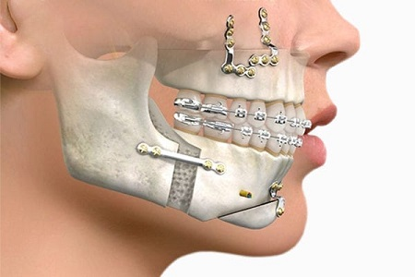

1. ORTHOGNATHIC SURGERY

It is done to correct conditions of the jaw and face related structures.

It is also referred as corrective jaw surgery.

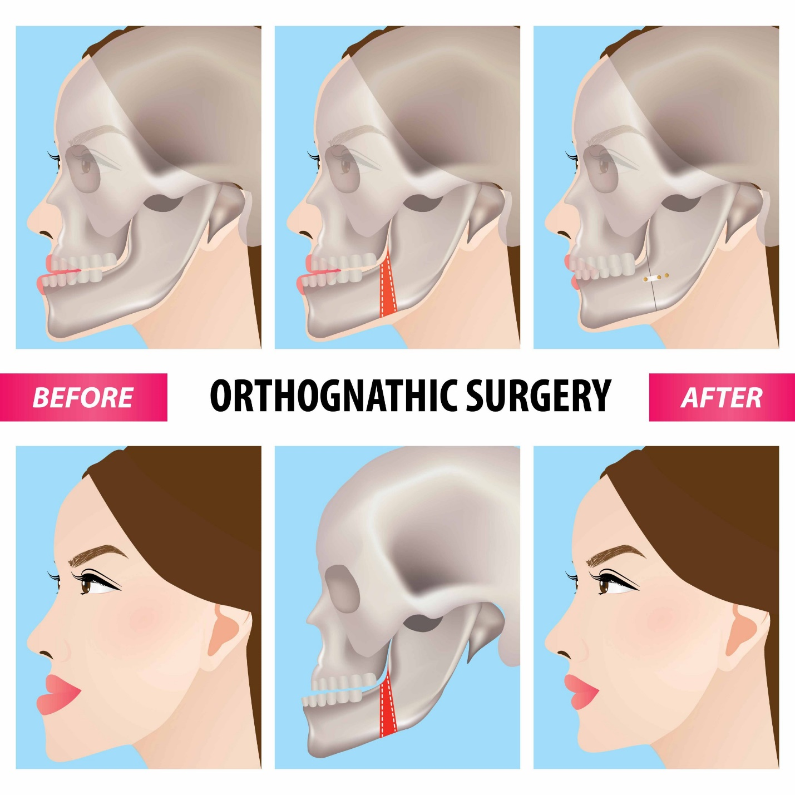

1. SURGICAL EXTRACTION

Surgical removal of tooth without pain

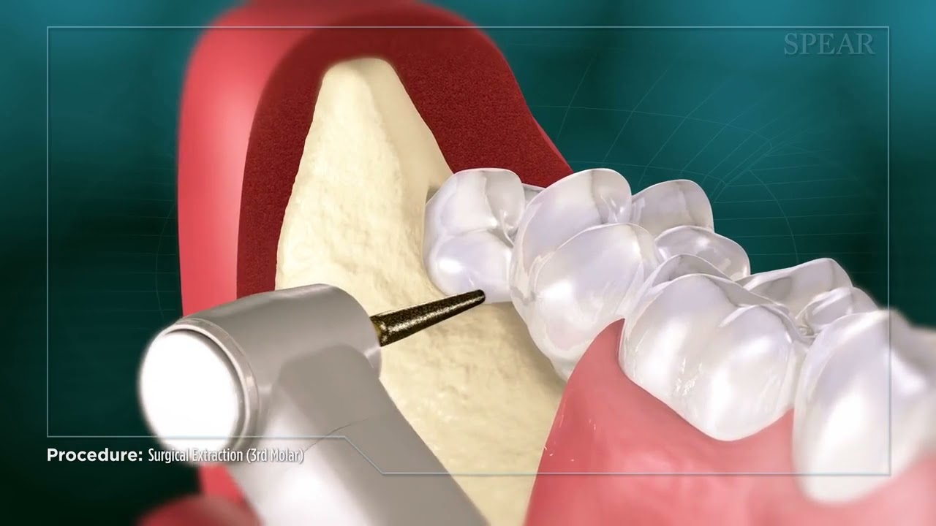

1. GUMLIFT

Gumlift is a cosmetic dental procedure that raises and sculpts the gum line. This procedure is typically done to reduce excessive gummy smile.

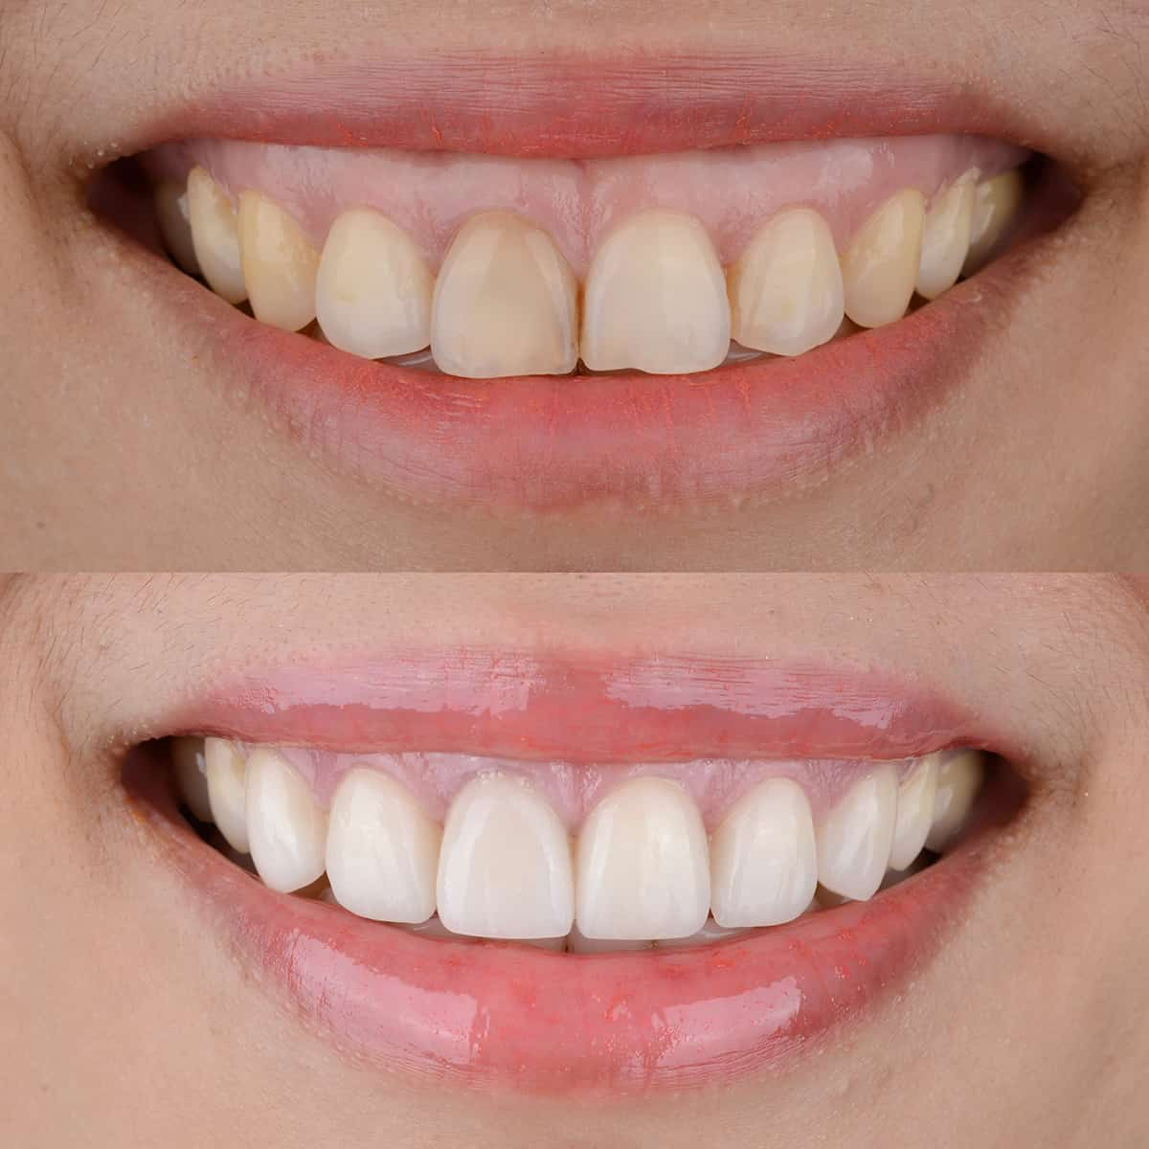

1. COSMETIC DENTISTRY

It refers to a series of dental treatments to achieve a better smile, It includes orthodontic treatment, tooth color restorations &veneers.

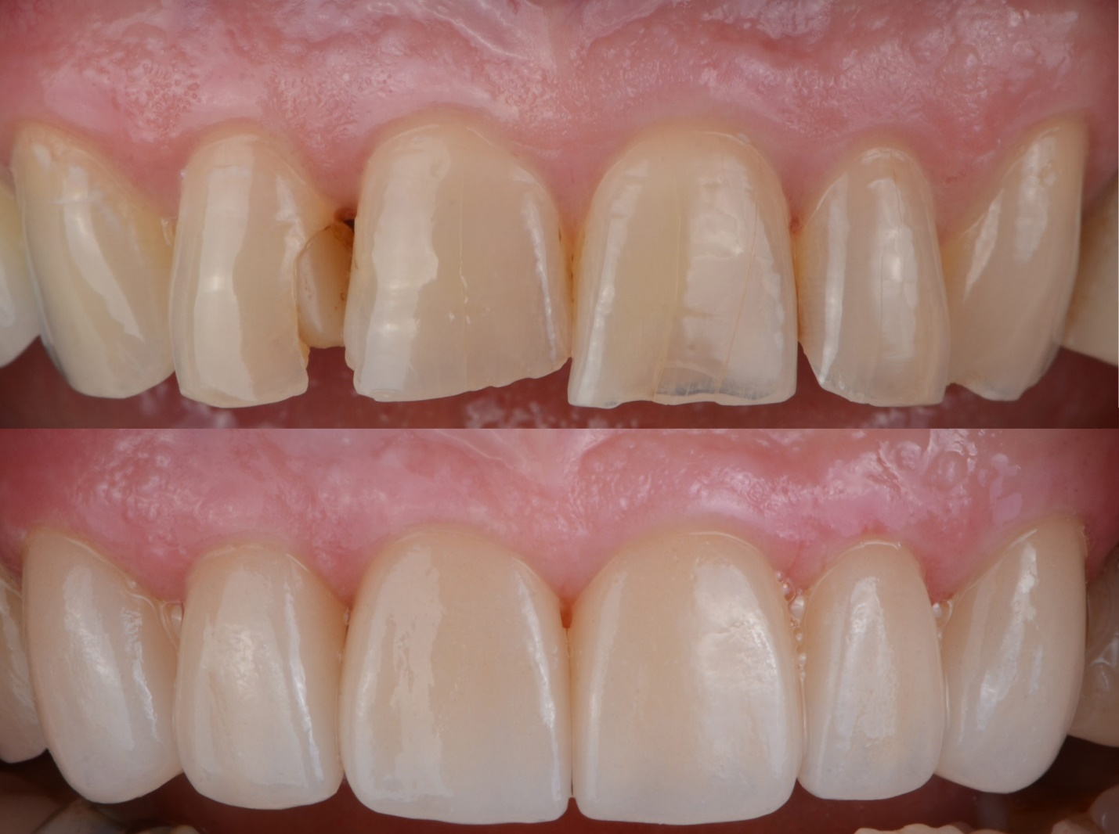

1. TOOTH WHITENING

It lightens tooth color and helps to remove stains and discoloration. Whitening is one of the most popular cosmetic dental procedures because it can greatly improve how your teeth look.

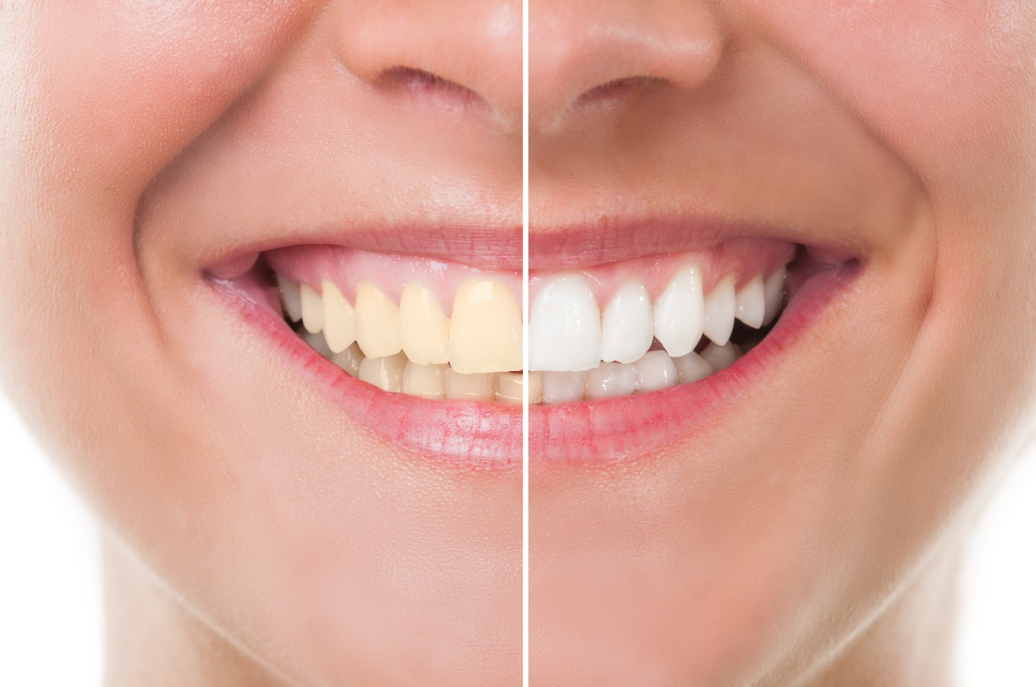

1. VENEERS

Veneer is a thin layer of restorative material placed over a tooth surface either to improve the aesthetics of the tooth or to protect a damaged tooth surface.

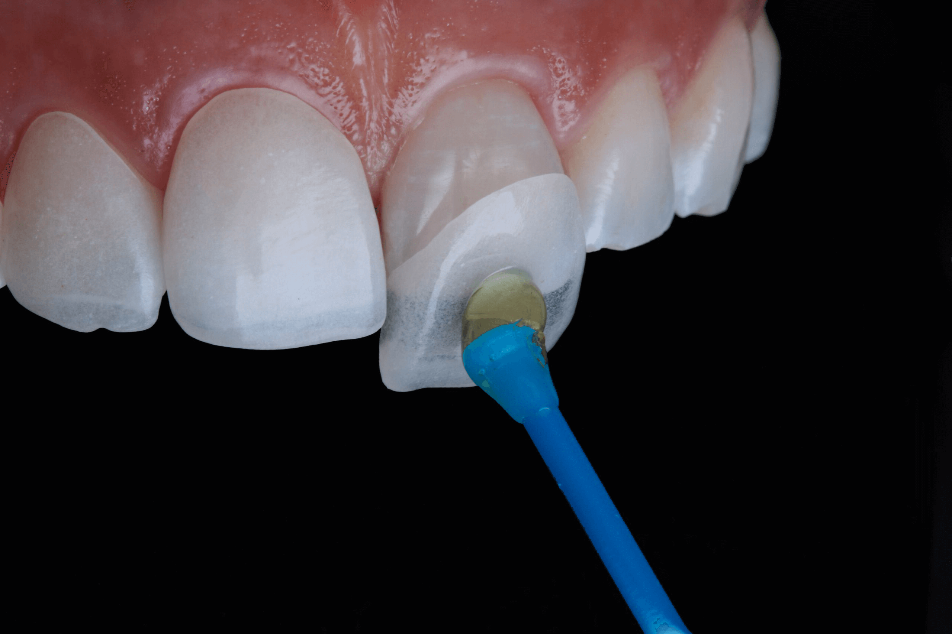

1. CLEAR

ALIGNER SYSTEM:

A BEAUTIFUL SMILE

WITHOUT BRACES

Invisalign is the most advanced clear aligner system in the world.

Each feature is designed to reveal the smile that you deserve.

Because it's not just your smile that's full of potential.

• REMOVABLE

• COMFORTABLE

• NEARLY INVISIBLE

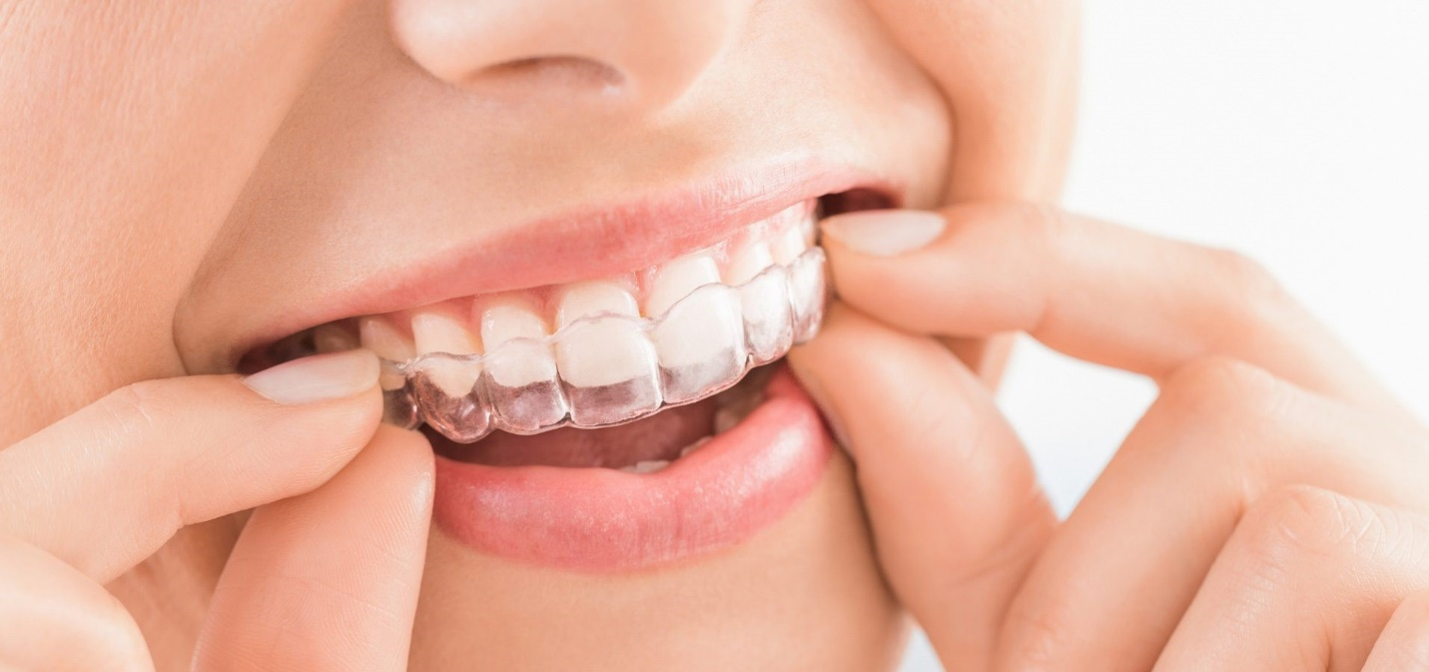

1. Pediatric Dentistry

